**HUMAN RESOURCE MANAGEMENT SYSYEM**



**Relben Mazambara**

**Human Resource Management System**

Submitted in partial fulfilment of the requirement for the

**BSc. Honours Degree in Business Studies and Computing Science**

**(HBSCTC Level 2.2)**

Department of Computer Science in the

Faculty of Management Sciences and Economics at the

**University of Zimbabwe**

P. Bag 167

**Mt Pleasant**

**Harare**

**Zimbabwe**

September 2021

**Supervisor: Mr. Munyaradzi**

**ABSTRACT**

The aim of the project was to develop a secure and user friendly system that prompt efficient and effective management of employees by the management committee. It was developed to eliminate costs associated with manual processes. Waterfall model was used as a methodology to develop the system. Interviews, questionnaire and direct observation were used as data gathering methodologies. These data gathering methodologies were used to gather information about how the manual system caused problem to employees and the organization and also gathering data about the user expectations to the new system. The development of the system plays an important role to the organisation since it eliminates the problem stated in the HRM system problem; improves quality of reports used for decision making and reduced stationery cost. Technologies used for system development includes Java, MySQL database, Eclipse IDE, Arduino IDE.

**DECLARATION**

Lordme Chimudzi and Relben Mazambara hereby declare that we are the author of this thesis. We authorize University of Zimbabwe to lend this thesis to other institutions or individuals for the purpose of research.

Signature ………………………………………….

Signature ………………………………………….

Date ……/………/……

**APPROVAL**

This dissertation entitled HUMAN RESOURCE MANAGEMENT SYSTEM application done by Lordme Chimudzi and Relben Mazambara meets the regulations governing the award of the degree of BSc Honours Business Studies and Computing Science of University of Zimbabwe, and is approved for its contribution to knowledge and literal presentation.

Supervisor’s Signature………………………………............................................

**ACKNOWLEDGEMENTS**

For this project to be a success, we would like to thank God (Jehovah) for the time we had to prepare this project. I also express my sincere gratitude to our project supervisor Mr Munyaradzi who has been very kind and considerate by providing us with an opportunity to work and supervising this project. We are also thankful to the Chairman of Computer Science department Mr. Mapako for his contribution. We also thank Ruya Adventist High School for all the information they provided in fostering the completion of this study. We also thank Obert Kadzomba for his effort in doing database design and the rest of the college staff for their collaboration. May the almighty father (Jehovah) richly and abundantly bless them for the good work they have done.

**Table of Contents**

**CHAPTER 1: INTRODUCTION** 10

**Background** 10

**Background of the study** 10

**Vision** 11

**Mission statement** 11

**Organisational structure** 11

**Problem Statement** 12

**Project aim** 12

**Objectives** 12

**Methods and Instruments** 13

**Table 1.1 Activity schedule** 13

**Table 1.2 Gantt chart** 13

**Project Justification** 14

**Summary** 14

**CHAPTER 2: LITRATURE REVIEW** 15

**Functional Requirements** 16

**Examples of system functional Requirements** 16

**Requirements specification** 17

**CHAPTER 3: METHODOLOGY** 19

**Information Gathering methodologies** 19

**Observation** 19

**Interviews** 20

**Questionnaires** 20

**Work plan** 21

**CHAPTER 4: SYSTEM ANALYSIS AND DESIGN** 23

**System design** 23

**Data Flow Diagram** 23

**Use Case Diagram** 24

**Architectural Design** 25

**User Interface Design** 26

**Process Design** 30

**Data Modelling** 32

**Entity Relationship Diagram (ERD)** 34

**Error handling** 35

**CHAPTER 5: IMPLEMANTATION AND TESTING** 36

**Testing plan** 36

**Validation** 40

**Maintenance** 43

**Performance Analysis** 44

**CHAPTER SIX: RESULTS AND DISCUSSION** 46

**Goal Achieved** 46

**User Manual** 47

**Further Work** 47

**REFERENCES** 49

**APPENDICES I** 50

**APPENDICES II** 53

**INTERVIEW RESPONSES** 54

**LIST OF ACRONYMS**

**HRMS- Human Resource Management System**

**ERD - Entity Relationship Diagram**

**ICT- Information Communication Technology**

**RFID- Radio Frequency Identification**

**UML- Unified Modelling Language**

**PC- Personal Computer**

**HR- Human Resource**

# **CHAPTER 1: INTRODUCTION**

This chapter gives the background of the organization, its strategic components and the services it offers to its clients. It went on to explain the problem statement, how is it adversely affect the school operations and how is it going to be addressed. The aim of carrying out this project is also stated. Methods and instruments were also specified to reflect how data is going to be gathered and how each step is going to be conducted. Gantt chart, Software, the Waterfall model and relevant programming languages are to be explained in this chapter. A justification of doing the project is also done.

## **Background**

Employees are the vital asset of an organization in as far as achievement of the organizational objectives is concerned. For the employees to produce a positive return to the organization, there is need for effective management of these employees since mismanagement would result in many drawbacks and costs. This is an information age era where the world is going digital and there is need to enjoy some technological advancement benefits. The motive behind the development of the human resources management system is for the effective and efficiency management of the employees by the human resources department in line with the organization’s objectives. The system creates an easy way of managing employee’s records and it has a user interface that is user friendly for the privileged users to manage their accounts, view reports and track records

### **Background of the study**

Ruya Adventist High School is a privately owned and controlled locally and located in Mt Darwin District in Mashonaland Central Province offering secondary education. It was opened in 2002 and it has an estimated number of employees of about 150 employees. It has three departments which are department of commerce, department of sciences and geography and the department of arts. The development of the Human Resource Management System is aiming to foster effective management of teachers and other workers by the school council to make sure that rules and regulations of the employment contract are properly followed for the benefit of the organization.

### **Vision**

Ruya Adventist High School has a vision to maintain quality results.

### **Mission statement**

Ruya Adventist High School’s mission statement is to be the leading provider of quality education in the district as well as in the country.

### **Organisational structure**

|  |
| --- |
| **ADMINISTRATIVE COMMITTEE** |

|  |  |  |  |  |
| --- | --- | --- | --- | --- |
| **Department of Commerce** |  | **Department of Sciences and Geography** |  | **Department of Arts** |

### **Problem Statement**

Manual handling of employee records and manual registration are resulting in many drawbacks. There is manual signing for attendance on daily basis will result in wrong information concerning time for attending duty for example an employee signing at 1000 hrs. Would just write 0700 hrs. as the time he started working. The use of papers and files may result in bias information since papers may end up in wrong hands in trying to speed up the process, for example when an employee is applying for a leave it will take too long to complete the forms by taking them to many offices along the organisational hierarchy and hard copies has a risk of being lost. Most current systems lacks self-service meaning that an employee cannot access and modify some of the information without conducting the management hence there is time wastage. Also most current systems are not capable of managing employee registration automatically. Additionally, many companies stores employee information at headquarters only so there may be a problem when sub companies or departments need to make immediate use of employee information.

## **Project aim**

Developing an application with a database and integrated with microcontrollers. The system will allow human resource manager to add employees, school council to monitor and manage employees and micro-controllers to take employee details and update attendance table automatically thereby maintaining accuracy in terms of time.

The Employee Management System will be responsible for enhancing tracking of employee records and effective management of employees by the school committee, hence it will foster the achievement of school strategic plan as stated by its vision and mission.

## **Objectives**

The objectives of the system are:

* Designing an Employee Management System that will be capable of performing employee registration, payroll processing, adding and removing employees, storing employee information, tracking employee performance, reports generation and leave management.
* Database to store employee information and details.
* Automation which will read employee data from employee identification card.
* A user friendly front-end for user to interact with the system.

### **Methods and Instruments**

Software used for the development of this system include Java, Eclipse IDE, MySQL database and Arduino IDE. Edraw application also used for modelling Entity relationship, use case, system architecture, Data flow and flow chart diagrams. My SQL used as the database technology for the system. Java used for coding interactive areas of the system. For data gathering questionnaires, interviews, and direct observation instruments were used on selected samples of students and staff.

### **Table 1.1 Activity schedule**

|  |  |
| --- | --- |
| **Project activity** | **Duration** |
| Proposal and introduction | 2 weeks |
| Literature review | 1 week |
| Methodology | 1 week |
| System design and analysis | 3 weeks |
| Implementation and testing | 1 week |
| Conclusions and recommendations | 1 week |

### **Table 1.2 Gantt chart**

|  |  |  |  |  |  |  |  |  |  |
| --- | --- | --- | --- | --- | --- | --- | --- | --- | --- |
| WEEKS  PROJECT ACTIVITY | 1 | 2 | 3 | 4 | 5 | 6 | 7 | 8 | 9 |
| Proposal and introduction |  |  |  |  |  |  |  |  |  |
| Literature review |  |  |  |  |  |  |  |  |  |
| Methodology |  |  |  |  |  |  |  |  |  |
| System design and analysis |  |  |  |  |  |  |  |  |  |
| Implementation and testing |  |  |  |  |  |  |  |  |  |
| Conclusions and recommendations |  |  |  |  |  |  |  |  |  |

## **Project Justification**

The system was designed to achieve a better way of handling the issue of managing the employees effectively hence achieves a competitive advantage over other schools. The system might also boost cooperate image, secure evaluation, satisfaction since both present and absent are granted equal chances to view and manage their accounts. The system compatibility with many devices and operating systems in this technological era would help the school to create smooth flow of employee issues since frustrations and disturbances caused by the manual system have been eliminated. In addition stationary cost for printing manual forms and letters was eliminated and also other cost in terms of time taken moving around many offices with manual papers would be allocated to other school productive services. Finally, all above mentioned aspects might shorten the organization’s journey to its vision and mission.

### **Summary**

In conclusion this chapter engraves issues that were being faced by the school and possible

Techniques that needs to be executed through the designing and implementation of system

to foster effective management. The next chapter is on literature review where there will be an analysis of the systems in use as well as the analysis of the proposed project.

# **CHAPTER 2: LITRATURE REVIEW**

This section is going to summarise the evaluation of the sources relevant to the Employee Management System. It examines theories, concepts, approaches, methods and techniques relevant to the project. Similar existing technologies relating to the development the Human Resources Management System are discussed.

A HRMS refers to the systems and processes at the intersection between human resource management and information technology. It merges Human Resource Management (HRM) as a discipline and in particular it’s basic HR activities and processes with the information technology field whereas the programming of data processing systems evolved into standardized routines and packages of enterprise resource planning software.

An organization or company with a very large number of employees manages a greater volume of data. This activity can be daunting without a more sophisticated tool to store and retrieve data. The various levels of sophistication can be examined by looking at the evolutionary aspects of HR technology. These aspects can be characterized into four stages of development: Paper-based systems, early personal computer technology, electronic databases and web-based technology.

The benefits of digitalization are becoming widely known and accepted to HR and other areas of the business. The focus has shifted to automating as many transactions as possible to achieve effectiveness and efficiencies as well as security of data. This technology allows for speedy access to accurate current information and reliability to access this information via multiple systems and this will create competitive advantage for the business.

HR is expected to relinquish its role as sole owner of HR information, so that managers and employees can use this information to solve their own problems using. This new system will not necessarily mean reduction in HR staff. The new system will enable HR professionals to focus on transforming information into knowledge that can be used by the organization for decision making. It will be about HR and ICT working together to leverage this technology.

A recent study by the Hackett Group, a business process advisory firm found that highly performing organizations spend 25 percent less than their peers on HR because they make use of the right technology effectively. The two most popular Web-based HR applications used today are self-service for employees and self-service for managers. These applications have enabled companies to shift responsibility for viewing and updating records onto individual employees and have fundamentally changed the manner in which employees acquire information and relate to their HR departments.

## **Functional Requirements**

Larman (2005) defines functional requirements as “statements of the services that the system must provide or descriptions of how some computations must be carried out”. It also include specification of what the system should do. The system involve Ruya Adventist High School stakeholders as the actors thus management, students and systems administrator. The systems administrator supervises and monitor the entire system for security and support.

### **Examples of system functional Requirements**

* The system should be interactive and user friendly to its stakeholders.
* The system should collect employee details using the automation.
* The system should prompt authorised managers to manage, view their accounts and track records anywhere anytime.
* Operating at low stationery cost.

**Examples of non-functional requirements include:**

* Performance- this is the time taken by the system to respond to given instructions.
* Scalability- this is the possibilities of expanding that is adding modules or respond to any changes that might be needed in the future.
* Availability- explained as the probability of a system providing requested services and data at the right time.
* Reliability- refers to the probability of having a system up and running without any complications.
* Security- involve measures and controls that can be employed to safeguard our system resources against attacks for example user authentication, database encryption.

The above stated non-functional requirements are very crucial for the new system to run swiftly.

Without security measures and controls this system could be vulnerable to attacks like Denial of service which might disturb the whole process. Such an attack would compromise the accuracy of generated outputs because it might lock the employees out of the system. Hacking is another attack that might also affect our system. By hacking an attacker can penetrate into the system and adjust the payroll system. Performance was also considered as a catalyst which foster efficiency and effectiveness. Scalability also considered to be very useful in the event of upgrading legacy systems, integrating or adding some functional modules to the system.

## **Requirements specification**

Technical expert (the author), resources and technology needed were in place. Firstly network infrastructure was already there in the existing system. Other resources like database and PCs where the system was going to be connected to were also available. On software side tools needed for coding: PHP, Dream Weaver, and Java Script were also available.

**User Requirements**

User’s needs:

* Basic knowledge of Information systems
* Training.
* Well educated and skilled especially those with other rights in the system.

**Hardware Requirements**

1. HP backup server with the following minimum specifications

1. 4G RAM
2. Pentium iv processor
3. 2.4 GHz processor speed0
4. NodeMCU
5. RFID Tags (**13.56 MHz**)
6. MFRC522 RFID Reader
7. Bread Board
8. Jumper Wires
9. Micro USB Cable
10. 2 LED (red and green)

**Software Requirements**

Software specifications

**Table 2.1**

|  |  |  |
| --- | --- | --- |
| **Software** | **Version required** | **Software available** |
| Operating system | Windows 7,8,10 | Windows 10, 64 bit |
| Eclipse IDE | 2021.0.1.3 |  |
| XAMP(localhost) | 5,6 | 5,6 |
| Arduino IDE |  |  |

# 

# **CHAPTER 3: METHODOLOGY**

## **Information Gathering methodologies**

For this report to complete the following information gathering techniques were used: interviews, questionnaires and observation. The main objective for using such techniques was to enhance analysis of the existing manual system from school’s stakeholder perspective as well as to come up with a clear picture of the system requirements. System users conducted to supply information were including ICT staff, Information Desk staff and teachers and students.

Below are the techniques used for gathering information:

### **Observation**

This technique employed through studying the existing manual evaluation system. It helped the designer to know the way in which employee queries and how they are handled. It also helped the designer to know the time management tactics of the employees.

**Benefits of Observation**

* It provided the researcher with first-hand Information.
* Unlike questionnaires the researcher was able to see the participant emotions, behaviour and feelings.
* It enhanced provision of permanent records which may be used in the future when system needs to be tested and upgraded.

**Drawbacks of Observation**

* Consumed a lot of time hence delays the project.
* It also demanded a large number of researchers especially when the population to be observed is large. However, it brings in an element of subjectivity hence compromise system quality.

### **Interviews**

The researcher have also used interviews to collect data. An interview refers to face-to-face communication between two or more people in order to obtain information.

**Benefits of Interviews**

* It was an easier way of screening and it helped the analysis team to come up with the information required for system decision making process.
* It also helped the interviewer to control the process to keeping the interviewee on focus of what was asked.
* It helped the researcher to capture both verbal and non-verbal communicating techniques hence facilitate the interviewee to use both verbal signs to express their views.
* Helps the interviewer to capture qualitative information from there interviewee especially by observing reaction.

**Drawbacks of interviews**

* Quality of data gathered depends on the interviewer if he or she has less questioning techniques then it implies that the results produced might be less effective. However in this case the researcher has enough techniques and skills hence the interview was successful.

### **Questionnaires**

On this technique both free and fixed formats questionnaires were used because of their advantages on different groups. Free format questionnaires were specifically designed and distributed to those who understand IT in depth. Fixed formats were designed and distributed to other non I T staff and students. The use of this questionnaires helped the researchers to design the actual user requirements, objective and constraints. In addition the use of questionnaires with more fixed and less free formats to novice users helped our questionnaire compiling time to produce statistical data. Also the use of questionnaires with less free formats and less fixed format for ICT experts accelerate the achievement and citation of specific areas.

**Benefits of questionnaires**

* It conducted in a practical way.
* Questionnaires results were easy to quantify through the use of statistical software.
* More data collected from a large sample in a small time and least cost effective way.

**Drawbacks of questionnaires**

* Unlike observation it was difficult to measure participant’s emotion, behaviour and feelings.
* It was difficult to know how true the respondent was.
* Validity of a questionnaire was a problem.

Some of the research documents are attached in this document under appendix page

## **Work plan**

Tables below shows how project activities are going to be conducted against time. The work plan schedule was done using a Gantt chart technique basing on 6 stages. This project schedule help us to keep project activities on course since it discourages assignment of project racecourses to unproductive activities. Work plan also make project tracking and monitoring easier since it plainly shows project milestones hence lead to production of a quality system.

**Table 3.1 Activity schedule**

|  |  |
| --- | --- |
| **Project activity** | **Duration** |
| Proposal and introduction | 2 weeks |
| Literature review | 1 week |
| Methodology | 1 week |
| System design and analysis | 3 weeks |
| Implementation and testing | 1 week |
| Conclusions and recommendations | 1 week |

**Table 3.2 Gantt chart**

|  |  |  |  |  |  |  |  |  |  |
| --- | --- | --- | --- | --- | --- | --- | --- | --- | --- |
| WEEKS  PROJECT ACTIVITY | 1 | 2 | 3 | 4 | 5 | 6 | 7 | 8 | 9 |
| Proposal and introduction |  |  |  |  |  |  |  |  |  |
| Literature review |  |  |  |  |  |  |  |  |  |
| Methodology |  |  |  |  |  |  |  |  |  |
| System design and analysis |  |  |  |  |  |  |  |  |  |
| Implementation and testing |  |  |  |  |  |  |  |  |  |
| Conclusions and recommendations |  |  |  |  |  |  |  |  |  |

# **CHAPTER 4: SYSTEM ANALYSIS AND DESIGN**

This chapter gives a detailed description of how the system components are entwined and communicates. It mainly stresses on the design techniques used and move on to diagrammatically shows how processes and data communicates; flows and modelled using DFDs, Use Case, Flow Charts and ER diagrams. It went on to show how the new system user interface were designed to come up with simple, user friendly menu, input and output design. Backup design should also be covered to articulate how it is going to be done. Data validation, verification and error handling would conducted in detail through data backup design and also how defence in depth components like firewalls and other security aspect should employed to achieve less compromised security for the system. Lastly this chapter depicts how test data and deployment designs should employed to foster a clear understanding on how deployment diagram translates to system works.

## **System design**

According to Strickland (2014) “System design is the process or art of defining the architecture,

components, modules, interfaces, and data for a system to satisfy specific requirements”. Unlike the existing manual system the new system enhances tracking of records to the authorised users only. Employees would view reports anytime, anywhere without compromising their

working time and this fosters effective communication. Below are levels of DFDs which shows how the new system processes and entities communicates to show how the new system works to achieve stated objectives.

### **Data Flow Diagram**

According to Grady (2010) “The context-level data flow diagram shows the interaction between the system and the external agents that acts as data sources and data sinks”. It also depicts the whole system as one process without details of the internal organisation. It is then expanded to produce level zero data flow diagram (Grady, 2010) as shown by fig 4.1 below

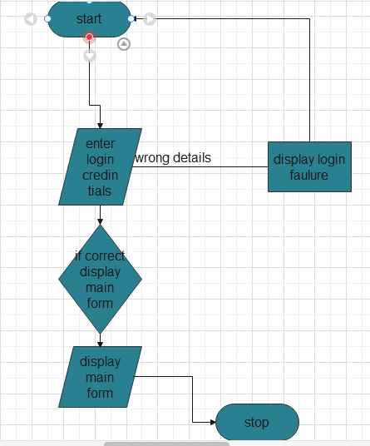

**Figure 4.1**

### **Use Case Diagram**

According to Egger (1998) “A use case describes a series of action taken by the system once an actor gives a stimulus.” Figure 4.2 shows a diagram made up of HR manager allowed to perform any transaction in the database and employee allowed to manage their accounts and view reports only as actors. Use case diagram used because it shows how the system actors interact and conduct transactions in the new system.

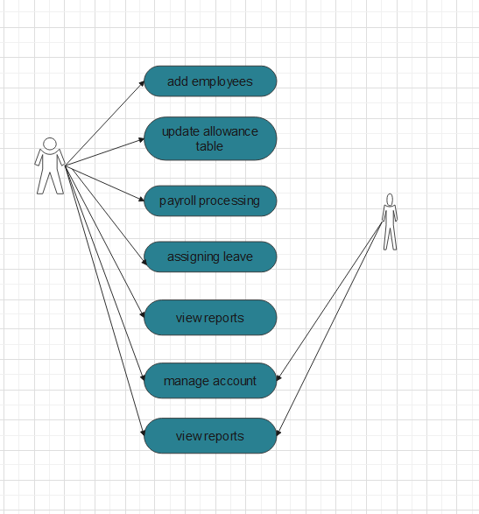

**Figure 4.2**

## **Architectural Design**

According to Strickland (2014), “system architecture is an architectural description of the conceptual design that defines the structure and/ or behaviour of a system.” Figure 4.3 depicts an architectural design which shows components that made up a system and how are they networked. This design will help system designer, analyst and other expert system users to understand how the system components are interlinked as shown below.

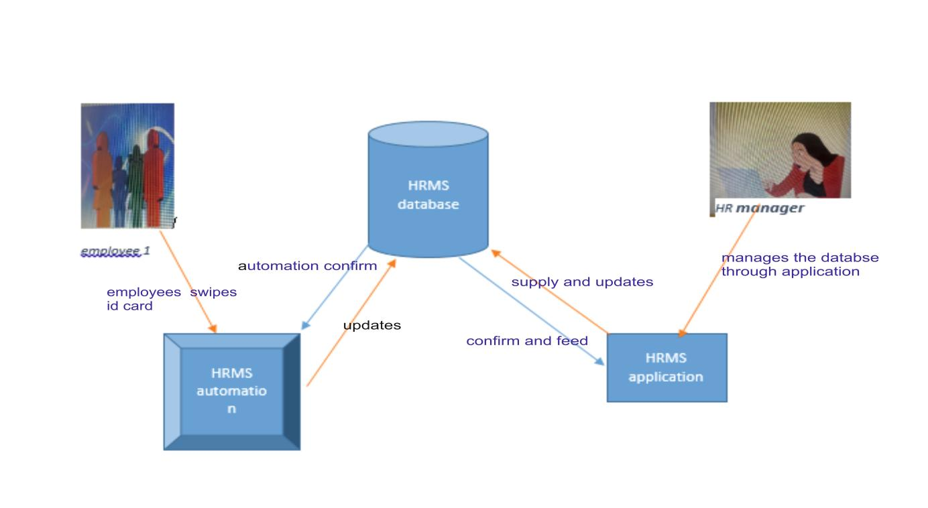

**Figure 4.3**

**User Interface Design**

**Menu Design**

Figure 4.4 shows a designed main menu interface for the system. As shown the interface has nine Links shown to the left navigation bar in which the settings show options like change dashboard, employees, manage employees, attendance, leaves, payrolls, add user, set up and system logout when clicked. The options will depend on the privileges granted to the user when he or she added to the system. In addition the report link when clicked will give management, systems administrator and the employee to view evaluated report according to privilege granted. Access privileges are granted to users to foster database security.

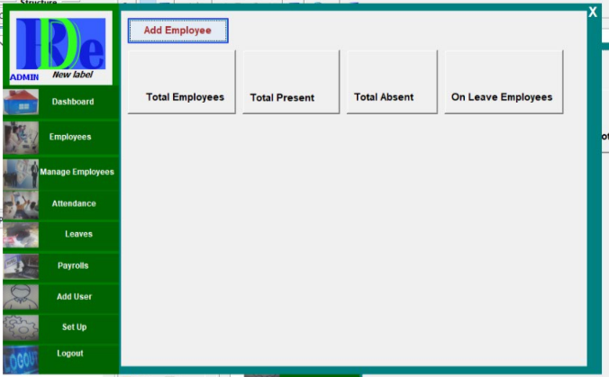

**Fig 4.4 menu design**

**Input Design**

Figure 4.5 Input design Interface is the interface used by all system users to log in to the

System. This interface requires the user to enter the username which is the unique identifier

and the default password granted by the systems administrator when the user is log in to the

System for the first time. When the user log in to the system he/ she will prompted for an

option to change the password.

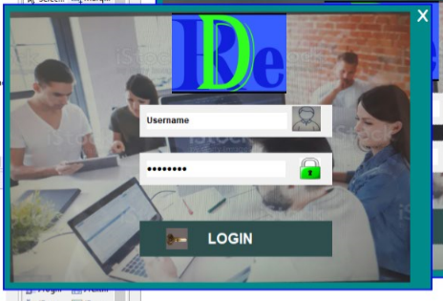

**Fig 4.5 Adding an employee design**

**Fig** 4.6 is the interface to be displayed if the user is adding an employee in the system

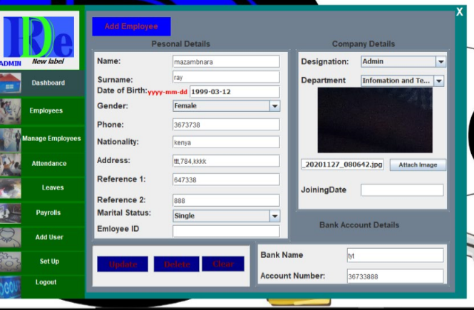

**Fig4.6: adding an employee design**

**User adding and removing by the management design**

**F**ig 4.7 is the interface for both adding and removing an employee from the system.

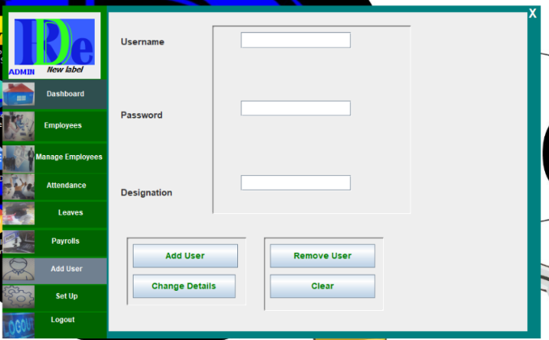

**Adding allowances interface**

Fig 4.8 is the interface when allowances are to be added to employees

**Fig 4.8**

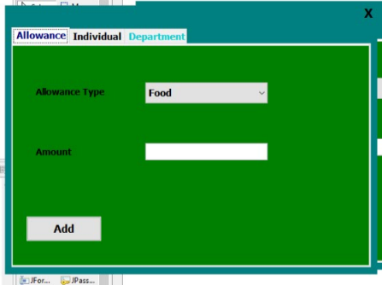

**Payroll system**

Fig 4.9 is the interface for payroll processing, the admin will just type an employee id and surname and name will be selected from the database. Then the admin will then type salary, number of hours and some deductions will done automatically after that the admin can execute the payment. The process will be save in the database.

**Fig4.9**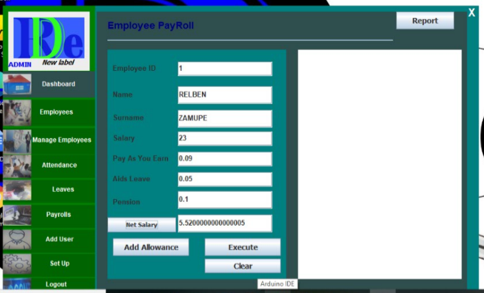

**Logout design**

Fig 4.10 is the logout interface, after the user finished all the operations in the system he can logout by clicking logout label. After clicking, a dialogue box pops out asking if the user is sure about the click, a user can confirm and the dashboard will be invisible, automatically the login form becomes visible.

**Fig 4.10**

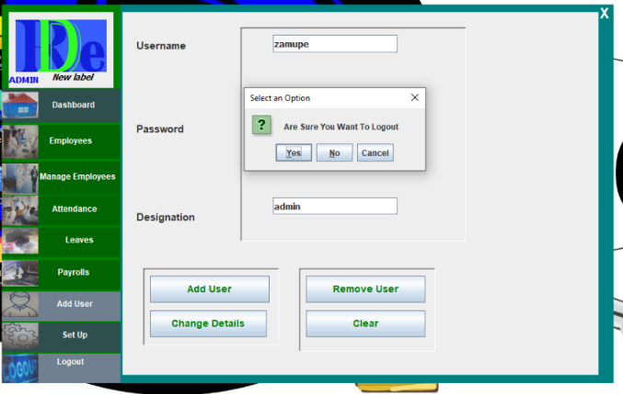

### **Process Design**

According to Meyer (2009) “Pseudocode is informal text standing for program elements to be added later” Statements written below signifies an example of pseudocode it shows steps to be taken when system coding is conducted or tit shows each and every step to be done by the user.

**Pseudocode**

*Start*

*Visit the application*

*Login to the application*

*Validate information entered*

*IF the data is entered in correct field is correct*

*THEN allowed to enter in the system*

*Else highlight areas which needs correct data input*

*IF password is incorrect*

*Contact HR manager for registration or verification of details*

*ELSE*

*exit*

*End*

**Flow chart**

According to Vallabhaneni (2013) “a flowchart is a graphical presentation of a sequence to activities and decisions.” Figure 4.11 shows sequence of activities from the time the user log in and transactions made until logout. A flow chart is used in HRMS because it can be understood by non-programmers.



## **Data Modelling**

**Table 4.12: Employees details dictionary table**

**Primary key: employee id**

|  |  |
| --- | --- |
| **Column name** | **Data type** |
| Employee id | Int (11) |
| Name | Varchar (50) |
| Date of birth | date |
| gender | text |
| Phone | Int(10) |
| Address | text |
| Reference 1 | text |
| Reference 2 | text |
| Marital status | text |
| Joining date | date |
| Department | text |
| Banking details | varchar |

**Table 4.13: Leave table**

**Primary key: id**

**Foreign Key: Employee id**

|  |  |
| --- | --- |
| **Column name** | **Data type** |
| Id | Int(11) |
| Leave type | Varchar(255) |
| from | date |
| to | date |
| Employee id | Int (11) |

**Table 4.14: Login table**

**Primary key: login id**

|  |  |
| --- | --- |
| **Column name** | **Data type** |
| Login id | Int(11) |
| username | Varchar(30) |
| Password | Varchar(20) |
| designation | text |

**Table 4.15: Allowance table**

**Primary key: id**

**Foreign key: employee id**

|  |  |
| --- | --- |
| Id | Int(11) |
| Allowance type | Varchar(11) |
| Amount | float |
| Employee id | Int(11) |

**Table 4.16: Check in time table**

**Primary key: employee id**

**Foreign key: employee id**

|  |  |
| --- | --- |
| id | Int(11) |
| date | date |
| time | date |
| Employee id | Int(11) |
|  |  |

**Table 4.17: Check out time table**

**Primary key: id**

**Foreign key: employee id**

|  |  |
| --- | --- |
| **Column name** | **Data type** |
| Id | Int(11) |
| Employee id | Int(11) |
| Date | Date |
| time | date |

### **Entity Relationship Diagram (ERD)**

An entity–relationship model (ER model) describes interrelated things of interest in a specific domain of knowledge. A basic ER model is composed of entity types (which classify the entities

of interest) and specifies relationships that can exist between instances of those entity types. In software engineering, an ER model is commonly formed to represent things that a business

needs to remember in order to perform business processes. Consequently, the ER model becomes an abstract data model, that defines a data or information structure which can be implemented in a database, typically a relational database. This analysis is then used to organize data as a relation, normalizing relation and finally obtaining a relation database.

**ENTITIES:** Which specify distinct real-world items in an application.

**RELATIONSHIPS:** Which connect entities and represent meaningful dependencies between them as shown on figure 4.18 below.

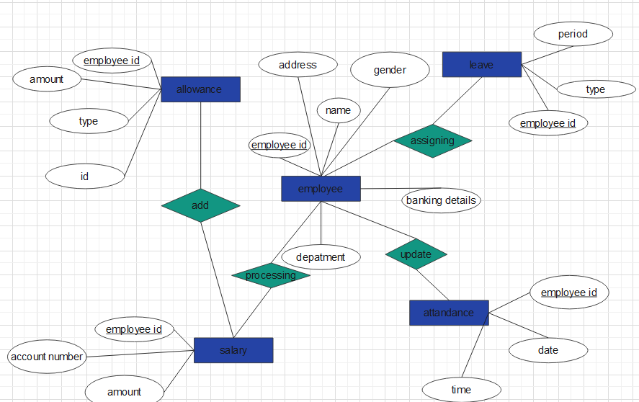

### **Error handling**

This is the prediction, searching and implementing possible solution in system development errors. During the development of this system special error handlers are embedded in the code. When errors are noticed during system operation a flag is raised or it can be rectified without compromising system transaction. Errors encountered are saved in the errors information log file such that they can be dealt with by the system developer. Example of errors that this system is designed to prevent and solve involve:

* Syntax errors –these errors might occur in syntax, and possible measures are done to show and eliminate them. This error example involve making mistake in typing password and characters hence the system is designed to validate as well as generating warning and error message.
* Another error is the logic error or bugs. The system is designed to solve this type of error by debugging. For example each and every system module went through a debugging process when completed. This error handling is an ongoing process.

# 

# **CHAPTER 5: IMPLEMANTATION AND TESTING**

This chapter translate what was cited in the design phase to a new system to be deployed to project clients. It further divided into the following areas:

* Maintenance.
* Performance analysis.
* System testing

## **Testing plan**

|  |  |  |  |  |
| --- | --- | --- | --- | --- |
| **Test case** | **Why testing** | **Testing Condition** | **System expectation** | **Actual Results** |
| **Login** | Validate login credentials | System should refuse access to  unauthenticated users. | If incorrect Login  credential are used the system displays a warning message | Allowed to enter into the system |
| Add a new employer | To make sure that  system user are  added successfully  with respect to their department and granted privileges which cannot  compromising there  transactions | The user should not be added more than once.  Upon registration the user should assigned a default password which  must be changed as soon as he or she login to the system for the  first time | Shows a message which reminds the management  that the user is already  existing in the system. | A successful  message is  displayed when  the user is added  for the first time |
| Assigning leaves | Making sure that the leave is assigned to an employee that is already on leave | System should allow the exact employee to be assigned a leave backed up by employee details supplied | Shows a massage that reminds the management that employee is already on leave. | A successful massage to be shown if successfully assigned a leave |
| Making a payroll | Validating the account details and the employee id | It should allow payroll processing | Shows the massage that, ID is not correct or not matching employee details in the database. | A successful massage to be displayed |
| Employee attendance | Taking employee id and the connect it to the employee details and recode time of checkout and check-in. | If the id card is registered the system must allow and turn on a green light for some seconds and if not it must turn on a bazar and a red light showing unauthorised access. | red and a bazar for unauthorised | Showing green light for registered |

**Figure 5.1**

**Evaluation of different testing strategies used.**

Testing design facilitated the developer to carry out a strategic testing analysis to ensure that

System requirements were accomplished through series of testing techniques. This evaluation

enhance system designers and developer to deliver what was expected for the system by the users. Functional requirements achievement were facilitated in this system by use of testing strategies since defects were identified and corrected. It was very impossible for the developers to have testing technique that give surety of a zero defect system. Implementation of testing strategies promotes risk mitigation and product quality.

* **Unit testing**

This is one of testing strategies firstly conducted by system developers using a white box testing

method. Using this strategy the developer tested system programs and modules to eliminate bugs

and checking possible ways to integrate the system modules to come up with quality system. The

developer use this strategy to check possibilities for integrating evaluation system application and database.

* **Integrated Testing**

HRMS system units were combined and tested as a group to display defects during the interaction of integrated modules. It is also conducted to check compatibility of system application and the database system. Integration testing was done before system testing

and after unit testing.

* **System testing**

Complete system software and integrated modules were tested to show the differences and

consensus of the existing system components to specified system requirements. Black box

testing used to conduct the evaluation system test and the testing process conducted by end users involved in the system development process. System modules, different system forms and the database were integrated before the testing is conducted. This testing conducted after integration testing but before acceptance testing.

* **Acceptance testing**

It is a type of black box testing, used to test the HRMS for acceptance. This testing is conducted to see if the system satisfies business requirements and end user needs. The developer conducted the testing process before the system is deployed. In HRMS system acceptance testing was done with end users in conjunction with system developers to highlight areas that might need to be revised.

Figure 5.2 shows a diagram of how testing strategies relate to each other.

|  |
| --- |
| Unit testing |

|  |
| --- |
| Integrated testing |

|  |
| --- |
| System testing |

|  |
| --- |
| Acceptance testing |

**Verification**

Verification is mainly focused on checking whether the system developed is effective. It checks to see if the system is satisfying user expectations as well as providing solution to the problem statement. Verification conducted because the system might be running whilst it is not meeting its intended goals. System users should also make use of the system during the testing process and confirm that it is meeting both user and system requirements. In this HRM system users will login in line with their granted privileges. Upon inserting login credentials the system will verify if the user is registered by checking with the database. If the user details are not found in the database then the system will not authenticate and give the user access.

### **Validation**

Validation also carried out to check whether the system is meeting organization needs and goals.

Different testing techniques were employed to check if the test data defined in the test plan and

check if the real data to be used in the system is accepted in correct format. Also the system is

checks unwanted situations and incorrect data entries and pop up errors messages

**Test data**

**Login Interface**

At login the core purpose is to validate the user name and the password. The condition to be tested involve entering a wrong username and password and the system will display an error notice as indicated in Figure 5.2.

Fig 5.2- **Expected outcome for entering wrong credentials at login.**

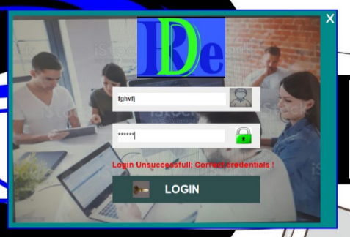

When the user enter correct login credentials the window shown in the Figure 5.2. The window links have sub links that prompt the user to commence system transaction depending on granted user privileges.

Fig 5.3

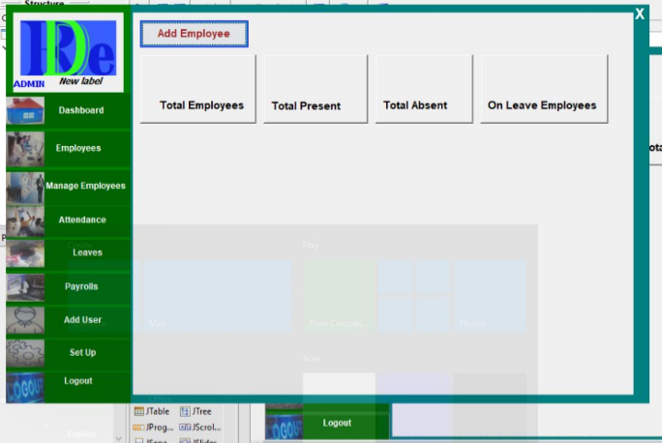**Create new employee**

This test case is there to measure if the system is able to create and add new users to the system.

If the user is successfully added to the system a message window indicated in Figure 5.4 is displayed to show that the user is successfully entered into the system.

**Fig 5.4**

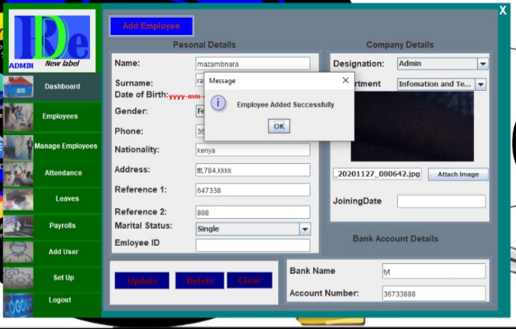

After adding an employee the database is updated as shown on fig 5.5 below.

**Fig 5.5**

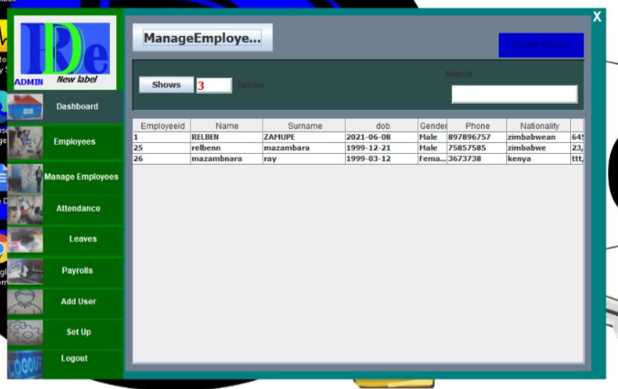

**Management report**

Fig 5.6 shows the report requested by the manager on a certain date displayed.

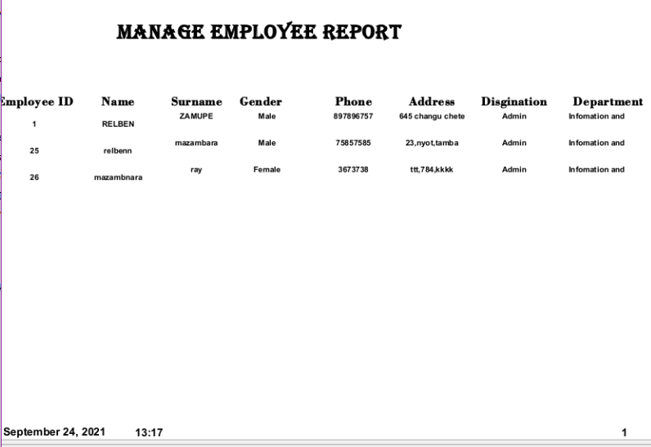

**Attendance**

If the employee swipes his or employee id card then the system, should update the database and the database will update the application under attendance as shown on figure 5.7 below.

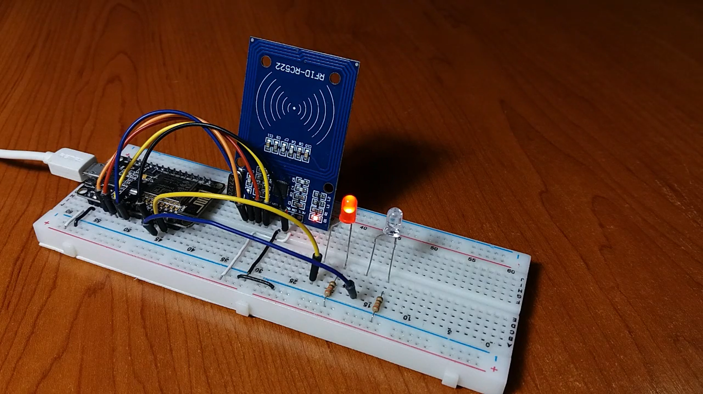

**Figure 5.7**

## **Maintenance**

After installation is done maintenance follows. As part of software life cycle maintenance conducted to keep the system in sync with changes in the technological environment. It also conducted to upgrade the system such that it could be compatible with new hardware and software. Maintenance is important since it used to foster speed, reliability and efficiency of the system, hence shortens a journey to organization strategic intent. The following maintenance strategies were used:

* **Corrective maintenance**

As the name indicates this strategy implemented to make a correction of errors that had arisen within the system operation. After the errors were corrected a documentation has been drafted to articulate steps and procedure that could be followed when such similar and related scenarios encountered. This strategy implemented when errors that could emanate from hardware and software changes encountered. In case of this system the version of MySQL database used would raise some issues that needs corrective maintenance strategies.

* **Adaptive maintenance**

This maintenance strategy implemented to facilitate the system to be usable in different environments for example the HRM system should be adaptive to different operating systems (Windows and Linux). The system should also be in a position to be integrated with other software. The system should also respond to changes in the environment without compromising system performance and reliability

* P**erfect maintenance**

This is mainly done to enhance changes to functional and non-functional requirements of the system. The HRMS user needs might keep on changing and this strategy is the one implemented to achieve new user and system requirements.

## **Performance Analysis**

* **Throughput**

The analysis conducted states that this system has a database which interacts with many users at the same time therefore to enhance reliability and efficiency; servers with good processing speed and high speed broadband is required to eliminate bottlenecks as well as fostering reliability.

* **Speed**

This include the response time this system takes to user queries. This system speed is awesome

because it uses drop down menu as well as options when the administrator add users to the system..

* **Services**

The online HRMS enhance updating of the attendance table by the use of micro controllers, facilitates management to view reports online and enable the systems administrator to add and view users in the system.

* **Security**

Since the system has a database an analysis conducted shows that system user’s duties are segregated hence when each and every user log in to the system he or she is automatically assigned his or her privileges. User are validated as they log in the system if there login credentials doesn’t match the system responds with an error message and the user will not be able to do transactions with the system.

# **CHAPTER SIX: RESULTS AND DISCUSSION**

This chapter discuses about the results of the work done during the development of the system. It

cover areas like the achievement of stated objectives. It also shows if the set objectives are partially, exceeded or fully achieved. It also shows parts of current work which is not completed due to time constraints and problems encountered.

## **Goal Achieved**

The objectives of the system are:

* Designing an Human Resources Management System that will be capable of performing employee registration, payroll processing, adding and removing employees, storing employee information, tracking employee performance, reports generation and leave management.
* Database to store employee information and details.
* An automation which will read employee data from employee identification card.
* A user friendly front-end for user to interact with the system

With reference to above stated system objectives the research and findings support these objectives to the extent that they were fully achieved. The first object is achieved since employees are able to register, payroll is being processed successfully, users are being added and removed and leave management is being done successfully.

By adding users in the system the Administrator will create an account for every user and give a username alongside with a default password. When the user which is not in the system tries to login, the system will not grant him access.

The second objective of database designing has achieved since employee information is stored and updated accordingly as well as security measures are implemented.

The third objective is achieved since microcontroller components are in place to take employee details by scanning employee id card. After collection of those details, the attendance table is updated automatically.

In line with the objective four, there is a graphical user interface to interact with users which is very user friendly and easy to navigate thereby creating room for non-Information Technology users to interact with the system.

In brief the system objective were fully achieved if not exceeded. However the system should be

further modified for user passwords to accept alphanumeric characters, also to time out the user who make login mistakes after a certain number of trials and the system needs to be integrated with the web page so that all the transactions would be done online.

## **User Manual**

The user manual state steps to be followed by the system users when using the system.

**User’s steps:**

1. Use the username and password provided by the administrator.

2. After login **PLEASE** change the default password to a strong alphanumeric password.

3. Click the option you want to do from the left navigation bar

4. Verify and confirm the actions done

5. **PLEASE** Logout.

**Management user steps:**

1. Use the username and the password provided by the administrator.

2. After login **PLEASE** change the default password to strong alphanumeric password.

4. Save or print generated report.

5. **PLEASE** Logout.

## **Further Work**

From the research and the development process conducted there is few work that might needs to be made. The system should be further modified for user passwords to accept alphanumeric characters and also to time out the user who make login mistakes after a certain number of trials. However, online evaluation system will be linked and integrated to organization website to share the domain name.

The employee id card will be used for security purposes such as unlocking organisation doors, systems and machines. The automation will add some components such as finger prints, camera and face detection technologies both with voice recognition which will be capable of learning employee voices for better recognition.

**Conclusion**

In conclusion the project was conducted successfully. Research conducted and findings satisfy stated system objectives. Some further work might need to be conducted to further system performance by integrating this system with other related systems as well as adding other components that would add swift functionality to the system. A manual which help users on how to install and use the system was also designed ranging from hardware to software specifications.

# **REFERENCES**

**1.** Bidgi H (19930) Information Systems Literacy (5th Edition), Macmillan Publishing

Corporation, New York.

**2.** Capron H.L (1995) Computer Tools for information Age (3rd Edition) Benjamin Cummings,

Menlo Park.

**3.** Cliff Butt, (1994) (Systems Analysis and Design for beginners)

**4.** Dologite, D.G and Mocker R J (1991) Microcomputers Prentice Hall, London

**5.** Hughes Aircraft Company, (1999) an improved Micro level Software Development

Resources Estimation.

**6.** James A.O Brien, (1996), Management Information systems

**7.** Marshal Mathers, (2000) Simulation and Modeling (Corporate Edition), Minnesota, LA.

**8.** O’ Leary, T.J and Willams, R.L (1999) Micro computing (7th Edition) McGraw-Hill book

company, New York.

**9.** Tannenbaum, AS.(1990) Structured Computer Organisations (3rd Edition),Prentice

Hall,London.

**10.** WWW.uasc.edu/learning material/systems and design/2003.html. Material produced by

professor J.K Miller, Open learning institute

# **APPENDICES I**

SAMPLE VIDEO LIBRARY SURVEY QUESTIONS

The questionnaire is purely for academic purposes. The researcher Relben Mazambara and Lordme Chimudzi are Level 2.2 HBSCTC Students at University of Zimbabwe. The research is being done to fulfil the requirement of the project, so feel free to respond to the questions on the questionnaire as all information is strictly for academic purposes.

SECTION A: SOCIO-DEMOGRAPHIC DATA

QUESTIONNAIRE NUMBER…………………………….

Age 18-26 26-35 36-45 46+

Sex Male Female

Period of employment: <=5months-1year 2-3years 5years+

Department……………………………………………………………………………………

Education Primary Secondary Tertiary Others

SECTION B

1.Describe some of the typical duties of your job…………………………………………………………………………………………………………………………………………………………………………………………………………………………………………………………………………………

2. In what ways area(s) are of the entire system operation of your organisation that you wish to be improved and How? ………………………………………………………………………………………………………………………………………………

3. Which Employee details do you actually use—and how often? (You may want to list the areas about which you would like feedback and have them check them off or rank them.) ……………………………………………………………………………………………………………………………………………….

4.What is the best way employee details could be handle in your organisation?…………………………………………………………………………………………………………………………………………………………………………………………………………………………………………………………………………………………………………………………………………………………

**How Employees Find Information**

5. What information sources do you regularly consult or have at your desk (or in your organisation)? ……………………………………………………………………………………………………………………………………………………………………………………………………………………………………………………………………………………………..

6. Where do you go if you want to update your details?

….…………………………………………………………………………………………………………………………………………………………

7. How successful are you usually in finding information? ..............................................................

8. How often do you not even look for information—or go to the administration—because you either thought you wouldn’t find it or it would be too much trouble or cost too much? …………………………………………………………………………………………………………………………………………..

9. What sort of frustrations and time delays are you encountering in finding information? ........................................................................................................................

**How clients Use the Library**

10. Do you refer others to the administration? Why or why not? ……………………………………………………………

11. Do you request an analysis of the retrieved information by the HR manager? .................................

12. Does giving your research problems to the administration save you time? .......................................

13. What is your preferred method of communication with the administration? Telephone? Email? Memo? IM? In Person? Other? If offered, would you use IM to contact the manager for help with a research problem? .........................................................................................................

14. Did you find what you needed? If not, what did you do next? (ask someone else, call the CEO, forget it) ………………………………………………………………………………………………………

**Open questions:**

What would you like to have happen as a result of receiving this information? .......................................................................................................................

How will this information enhance your work? .................................................................

How will we know when you have enough information to meet this particular need?

What methods have you already tried to find this information? .............................................................................................

Are there any products or other information sources of which I should be aware?

How urgent is this request? .......................................................................................

**Closed questions:**

What have you already found? .......................................................................................

How many examples do you need? .................................................................................

What is your deadline? What is the exact date the information is needed? ........................

To whom should the information go? ..................................................................................…

**Users Rate the System in Use**

* On a scale of 1 to 10, where 10 is the highest, please rate the following:

The System itself:

* Attractiveness of the facilities
* Convenience…………………………………
* Quiet places to work………………….
* Computer facilities (enough, up-to-date)……….
* Signage (enough, clear, attractiveness)………………..
* Location……………………………………
* Lighting………………………………….
* Comfort……………………………………….

The staff:

* Friendliness………………………………………….
* Willingness to help you………………………………
* Knowledge………………………………………………….
* Number (are there enough of them)………………………………
* Ease of use……………………………………………………….
* Ability to find needed information (was what you wanted there?)…………………………………………………
* Attractiveness……………………………………………….
* What one thing could the organisation do—or improve—that would help you most? ……………………………………………………………………………………….

......................................

# **APPENDICES II**

INTERVIEW GUIDE

The following guide is purely for academic purposes, so feel free to respond. This interview guide is mainly about Employees and their management.

QUESTIONS

FINDING ABOUT USER NEEEDS

How are you?

* Describe some of the typical duties of your job?
* In what are(s) do you need your organisation to upgrade?
* Which employee details do actually use and how often? (you may want to list the areas about which you would like feedback and have then check them off or rank them)
* Which information do you request regularly?
* What information sources do you regularly consult?
* How do you find information?
* How successful are you usually in finding information?
* What sort of delays are you accounting in finding information?
* Do refer to others to the management for information request?
* Which methods do you use ion communicating with the management?
* What things could the library do-or improve that would help you most?
* How well we know were doing good job, in your eyes?

## **INTERVIEW RESPONSES**

**INTERVIEWEE……………………………………………………………………………………**

**DATE…………………………………………………………………………………………………**

|  |  |
| --- | --- |
| **GUIDE NUMBER** | **RESPONSES** |
| **1** |  |
| **2** |  |
| **3** |  |
| **4** |  |
| **5** |  |
| **6** |  |
| **7** |  |
| **8** |  |
| **9** |  |
| **10** |  |